PMSCS 623P Quiz – 1 Fall, 2025

Student ID: Name:

- Analyze the running time of the following code segment and write it using O() notation.  int n = 16;  for(int i=5; i <=m; i=i++){  for(int j=5; j<=(2 × n); j=j++){  printf(“CSE 225”);  }  }  for(int k=n/4; k<=n/2; k=k++){  sum++;  } | 3
2.  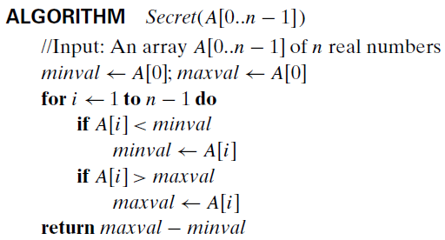 - What does this algorithm compute? - What is its basic operation? - How many times is the basic operation executed?  3. Perform Bubble sort algorithm for an array arr = {-15, -2, -9, -4, -7, -12, -18}. | 3  4

PMSCS 623P Quiz – 1 Fall, 2025

Student ID: Name:

- Analyze the running time of the following code segment and write it using O() notation.  int k = 16;  for(int i=5; i <=m; i=i++){  for(int j=5; j<=(2 × n); j=j++){  printf(“CSE 225”);  }  }  for(int p=k/4; p<=k/2; p=p++){  sum++;  } | 3
2.   - What does this algorithm compute? - What is its basic operation? - How many times is the basic operation executed?  3. Perform Bubble sort algorithm for an array arr = {-2, -7, -9, -4, -15, -12, -18}. | 3  4

PMSCS 623P Quiz – 1 Fall, 2025

Student ID: Name:

- Analyze the running time of the following code segment and write it using O() notation.  int n = m+1;  for(int i=5; i <=m; i=i++){  for(int j=5; j<=(2 × n); j=j++){  printf(“CSE 225”);  }  }  for(int k=n/4; k<=n/2; k=k++){  sum++;  } | 3
2.   - What does this algorithm compute? - What is its basic operation? - How many times is the basic operation executed?  3. Perform Bubble sort algorithm for an array arr = {-18, -7, -15, -4, -2, -12, -18}. | 3  4

